Instruction for Use
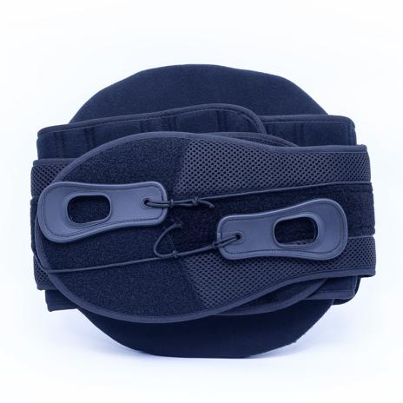

Common Examples of Use
Bulging or herniated disc
Decompressive procedures
Deconditioned trunk musculature
Degenerative disc disease
Facet syndrome
IDET procedure
Injections
Post laminectomy syndrome
Post-operative support
Sacroiliitis
Severe DJD
SI dysfunction
Spinal stenosis
Spondylolisthesis
Spondylosis
Sprain/strain
Radiculopathy

WARNING:
This product should be given by an treating doctor and applied by a professional. Application should be done with great care to ensure correct fit and efficiency of the brace. For hygiene reasons, it is proposed to be used by a single patient. Recommended product use up to 2 years.

WASHING INSTRUCTIONS:
Check the condition of the product before use. If it is worn off, it needs replacement.
Hand wash with cold water. Use a soft detergent and remove the pads.
Allow to dry on its own. Do not wash it in a washing machine or dry it in a tumble dryer.

